# Car Parking assistance:

Students:

Mohamad Ghoush   
Wafik Ibrahim  
Rein Ghattas  
Abed Al Rida Nehme

# Objective:

Our project’s objective was to make a parking system that offers the following features:

* Entrance and exit barriers equipped with IR sensors for car detection.
* A lcd to communicate with the entering car.
* 2 parking area each with 4 parking slots each equipped with an IR sensor to check availability.
* Guiling LEDs to help the entering car reach the nearest free parking slot.

# Sketch of connection:

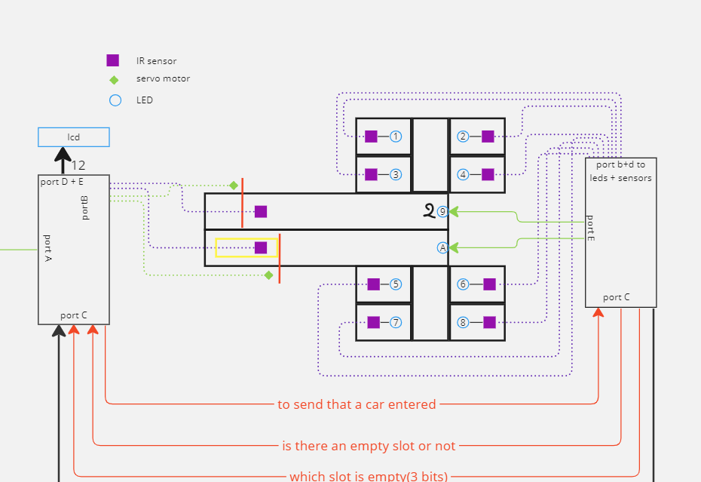

# Code:

**First PIC:**

INCLUDE "P16F877A.INC"

__CONFIG _CP_OFF & _WDT_OFF & _PWRTE_OFF & _BODEN_OFF & _LVP_OFF & _HS_OSC

REGB EQU 0X20

REG1 EQU 0X21

REG2 EQU 0X22

REG3 EQU 0X23

ORG 0X00

CONFI BSF STATUS,RP0

MOVLW H'EF'

MOVWF TRISC

MOVLW H'00'

MOVWF TRISD

MOVLW H'02' ; PORTA ANALOG ; PORTE DIGITAL

MOVWF ADCON1 ;

MOVLW H'00' ; PORTE OUTPUT

MOVWF TRISE

MOVLW B'00111111'

MOVWF TRISB

BCF STATUS,RP0

INIT CLRF PORTB

CLRF PORTC

CLRF PORTD

CLRF PORTE

CALL CONFILCD

CALL DELAY2S

MAIN MOVLW H'01'

CALL COMMAND

BTFSS PORTB,5

GOTO CAREXIT

BTFSC PORTB,4

GOTO MAIN

BSF PORTC,RC4

CALL WAIT

BTFSC PORTC,3

GOTO CARENTER

CALL NOSPACE

GOTO MAIN

CARENTER CALL HELLO

CALL OPEN_BARRIER

CALL WAIT2

CALL DELAY3S

CALL CLOSE_BARRIER

GOTO MAIN

CAREXIT CALL OPEN_BARRIERX

CALL WAIT3

CALL CAROUT

CALL DELAY3S

CALL CLOSE_BARRIERX

GOTO MAIN

OPEN_BARRIER MOVLW D'40'

MOVWF REGB

BSF PORTB,6

CALL DELAY1MS

BCF PORTB,6

CALL DELAY2MS

DECFSZ REGB

GOTO $-5

RETURN

CLOSE_BARRIER MOVLW D'40'

MOVWF REGB

BSF PORTB,6

CALL DELAY2MS

BCF PORTB,6

CALL DELAY1MS

DECFSZ REGB

GOTO $-5

RETURN

OPEN_BARRIERX MOVLW D'40'

MOVWF REGB

BSF PORTB,7

CALL DELAY1MS

BCF PORTB,7

CALL DELAY2MS

DECFSZ REGB

GOTO $-5

RETURN

CLOSE_BARRIERX MOVLW D'40'

MOVWF REGB

BSF PORTB,7

CALL DELAY2MS

BCF PORTB,7

CALL DELAY1MS

DECFSZ REGB

GOTO $-5

RETURN

HELLO MOVLW H'01'

CALL COMMAND

MOVLW H'85'

CALL COMMAND

MOVLW A'H'

CALL CHAR

MOVLW A'E'

CALL CHAR

MOVLW A'L'

CALL CHAR

MOVLW A'L'

CALL CHAR

MOVLW A'O'

CALL CHAR

MOVLW H'C1'

CALL COMMAND

MOVLW A'P'

CALL CHAR

MOVLW A'a'

CALL CHAR

MOVLW A'r'

CALL CHAR

MOVLW A'k'

CALL CHAR

MOVLW A' '

CALL CHAR

MOVLW A'S'

CALL CHAR

MOVLW A'l'

CALL CHAR

MOVLW A'o'

CALL CHAR

MOVLW A't'

CALL CHAR

MOVF PORTC,W

ANDLW H'07'

CALL TABLE

CALL CHAR

RETURN

NOSPACE MOVLW H'01'

CALL COMMAND

MOVLW H'87'

CALL COMMAND

MOVLW A'N'

CALL CHAR

MOVLW A'O'

CALL CHAR

MOVLW H'C5'

CALL COMMAND

MOVLW A'S'

CALL CHAR

MOVLW A'P'

CALL CHAR

MOVLW A'A'

CALL CHAR

MOVLW A'C'

CALL CHAR

MOVLW A'E'

CALL CHAR

RETURN

NOSPACE MOVLW H'01'

CALL COMMAND

MOVLW H'87'

CALL COMMAND

MOVLW A'N'

CALL CHAR

MOVLW A'O'

CALL CHAR

MOVLW H'C5'

CALL COMMAND

MOVLW A'S'

CALL CHAR

MOVLW A'P'

CALL CHAR

MOVLW A'A'

CALL CHAR

MOVLW A'C'

CALL CHAR

MOVLW A'E'

CALL CHAR

RETURN

CAROUT MOVLW H'01'

CALL COMMAND

MOVLW H'84'

CALL COMMAND

MOVLW A'C'

CALL CHAR

MOVLW A'A'

CALL CHAR

MOVLW A'R'

CALL CHAR

MOVLW A' '

CALL CHAR

MOVLW A'O'

CALL CHAR

MOVLW A'U'

CALL CHAR

MOVLW A'T'

CALL CHAR

RETURN

MOVE MOVLW H'01'

CALL COMMAND

MOVLW H'86'

CALL COMMAND

MOVLW A'M'

CALL CHAR

MOVLW A'O'

CALL CHAR

MOVLW A'V'

CALL CHAR

MOVLW A'E'

CALL CHAR

RETURN

DELAY1MS MOVLW D'05'

MOVWF REG1

MOVLW D'66'

MOVWF REG2

DECFSZ REG2

GOTO $-1

DECFSZ REG1

GOTO $-5

RETURN

DELAY2MS MOVLW D'05'

MOVWF REG1

MOVLW D'133'

MOVWF REG2

DECFSZ REG2

GOTO $-1

DECFSZ REG1

GOTO $-5

RETURN

DELAY3MS MOVLW D'1'

MOVWF REG3

MOVLW D'6'

MOVWF REG2

MOVLW D'166'

MOVWF REG1

DECFSZ REG1,F

GOTO $-1

DECFSZ REG2,F

GOTO $-5

DECFSZ REG3,F

GOTO $-9

RETURN

DELAY20MS MOVLW D'1'

MOVWF REG3

MOVLW D'25'

MOVWF REG2

MOVLW D'255'

MOVWF REG1

DECFSZ REG1,F

GOTO $-1

DECFSZ REG2,F

GOTO $-5

DECFSZ REG3,F

GOTO $-9

RETURN

DELAY2S MOVLW D'10'

MOVWF REG3

MOVLW D'255'

MOVWF REG2

MOVLW D'255'

MOVWF REG1

DECFSZ REG1

GOTO $-1

DECFSZ REG2

GOTO $-5

DECFSZ REG3

GOTO $-9

RETURN

DELAY3S MOVLW D'15'

MOVWF REG3

MOVLW D'255'

MOVWF REG2

MOVLW D'255'

MOVWF REG1

DECFSZ REG1

GOTO $-1

DECFSZ REG2

GOTO $-5

DECFSZ REG3

GOTO $-9

RETURN

TABLE ADDWF PCL,F

RETLW A'1'

RETLW A'2'

RETLW A'3'

RETLW A'4'

RETLW A'5'

RETLW A'6'

RETLW A'7'

RETLW A'8'

TABLE2 ADDWF PCL,F

RETLW A'A'

RETLW A'A'

RETLW A'A'

RETLW A'A'

RETLW A'B'

RETLW A'B'

RETLW A'B'

RETLW A'B'

WAIT BTFSS PORTC,5

GOTO WAIT

BCF PORTC,4

RETURN

COMMAND BCF PORTE,2 ; command mode

BCF PORTE,0 ;E=0

MOVWF PORTD ;BYTE TO BE SENT

NOP ; 1 MICROSECOND DELAY

BSF PORTE,0 ; E = 1

NOP ; PULSE DELAY

BCF PORTE,0 ; FALLING WITH THE E

CALL DELAY3MS ; TIME OF EXECUTION

RETURN

CHAR BSF PORTE,2 ; CHAR MODE

BCF PORTE,0

MOVWF PORTD

NOP

BSF PORTE,0

NOP

BCF PORTE,0

CALL DELAY3MS

RETURN

CONFILCD CALL DELAY20MS; WARMING UP

MOVLW H'3C'

CALL COMMAND

MOVLW H'0C'

CALL COMMAND

MOVLW H'06'

CALL COMMAND

MOVLW H'01' ; CLEAR SCREEN

CALL COMMAND

RETURN

WAIT2 BTFSS PORTB,4

GOTO WAIT2

RETURN

WAIT3 BTFSS PORTB,5

GOTO WAIT3

RETURN

END

**Second PIC:**

INCLUDE "P16F877A.INC"

__CONFIG _CP_OFF & _WDT_OFF & _PWRTE_OFF & _BODEN_OFF & _LVP_OFF & _HS_OSC

TEMP EQU 0X20

TEMPB EQU 0X22

COUNTER EQU 0X21

REG1 EQU 0X23

REG2 EQU 0X24

REG3 EQU 0X25

SLOT EQU 0X26

ORG 0X00

CONFI BSF STATUS,RP0

MOVLW H'FF'

MOVWF TRISB

MOVLW H'00'

MOVWF TRISD

MOVLW H'02' ; PORTA ANALOG ; PORTE DIGITAL

MOVWF ADCON1 ;

MOVLW H'00' ; PORTE OUTPUT

MOVWF TRISE

MOVLW H'D0'

MOVWF TRISC

BCF STATUS,RP0

INIT CLRF PORTD

CLRF PORTE

CLRF PORTC

CLRF COUNTER

MAIN BTFSC PORTC,4

GOTO CHECK

GOTO MAIN

CHECK BSF PORTE,0

MOVF PORTB,W

MOVWF TEMP

SUBLW H'00'

BTFSC STATUS,Z

GOTO NOTFOUND

LOOP1 BTFSC TEMP,0

GOTO FOUND

RRF TEMP,F

INCF COUNTER,F

GOTO LOOP1

NOTFOUND BCF PORTC,3

BSF PORTC,5

CLRF PORTD

GOTO MAIN

FOUND

MOVF COUNTER,W

MOVWF SLOT

SUBLW H'00'

BTFSC STATUS,Z

GOTO SLOT1

GOTO SLOTX

SLOT1 MOVLW H'01'

MOVWF PORTD

MOVWF PORTC

GOTO GUIDE

SLOTX MOVLW H'01'

MOVWF TEMP

DECF COUNTER,F

MOVF COUNTER,W

LOOP2 BCF STATUS,C

RLF TEMP,F

MOVF COUNTER,W

SUBLW H'00'

BTFSC STATUS,Z

GOTO PUTIND

DECF COUNTER,F

GOTO LOOP2

PUTIND MOVF TEMP,W

MOVWF PORTD

MOVLW H'F8'

ANDWF PORTC,W

IORWF SLOT,W

MOVWF PORTC

GOTO GUIDE

GUIDE MOVF PORTD,W

ANDLW B'11110000'

SUBLW H'00'

BTFSC STATUS,Z

BSF PORTE,2

BTFSS STATUS,Z

BSF PORTE,1

BSF PORTC,3

BSF PORTC,5

WAIT MOVF PORTB,W

MOVWF TEMPB

LOOPB MOVF TEMPB,W

SUBWF PORTB,W

BTFSS STATUS,Z

GOTO OFF

GOTO LOOPB

CSIGNAL BSF PORTC,0

OFF MOVF PORTB,W

ADDWF PORTD,W

BTFSC STATUS,Z

GOTO OFF

CLRF PORTD

CLRF PORTE

GOTO MAIN

END